# File permissions in Linux

## Project description

The project is about authorizing users with their appropriate permissions.

I have to examine existing permissions on the file system and also to determine if the permissions match the authorization that should be given. If they do not match, i will need to modify the permissions to authorize the appropriate users and remove any unauthorized access.

## Check file and directory details

I first started with checking which path i am currently in by using the pwd command. Then i listed all the directories and files located in that path which only turned out to be the projects directory. I then started checking the details of the files and directories even the hidden ones in the project directory so that i can check who has unauthorized access to which file/directory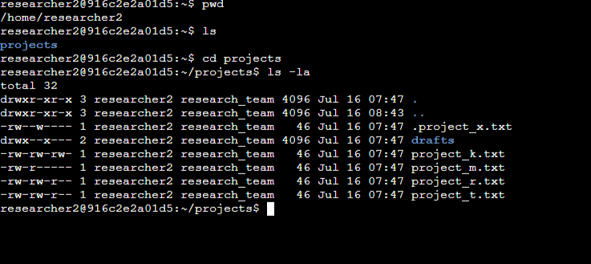

## Describe the permissions string

So the permission string contains 10 characters:

* The 1st character indicates the file type. The d indicates it’s a directory. When this character is a hyphen (-), it's a regular file.
* The 2nd-4th characters indicate the read (r), write (w), and execute (x) permissions for the user. When one of these characters is a hyphen (-) instead, it indicates that this permission is not granted to the user.
* The 5th-7th characters indicate the read (r), write (w), and execute (x) permissions for the group. When one of these characters is a hyphen (-) instead, it indicates that this permission is not granted for the group.
* The 8th-10th characters indicate the read (r), write (w), and execute (x) permissions for the owner type of other. This owner type consists of all other users on the system apart from the user and the group. When one of these characters is a hyphen (-) instead, that indicates that this permission is not granted for others

## Change file permissions

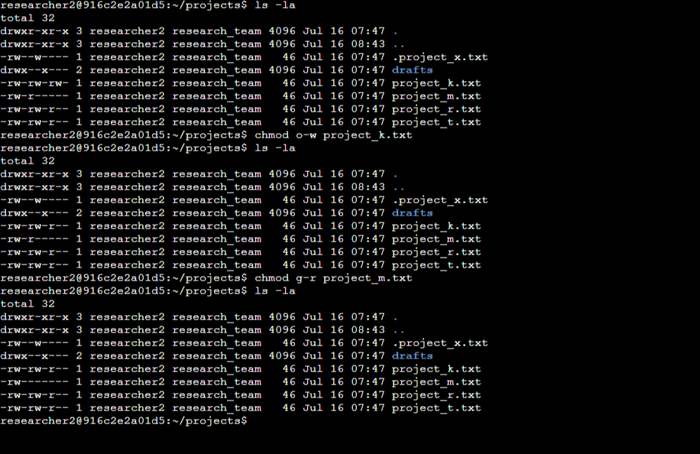

First i had to check if there is write permission for the other in the projects directory.If there is one i have to get rid of it

Since project k had the write permissions for the others,i had to remove that permission

Next,my boss instructed me to make project_m a restricted file and it had to be not readable and writable to the group and also the others. Since it only had the read permission of the groups,i just had to remove that.

## Change file permissions on a hidden file

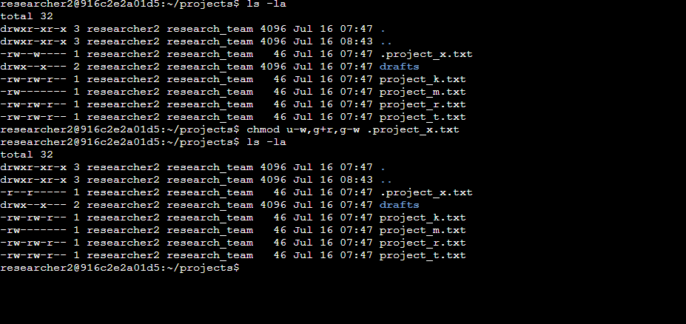

The project_x file is a hidden file that should not be written by anyone. So i had to change the permission of the user and the group and let them only read but not write or execute the file

I also had to make sure to start with . before the file name when changing permissions since it is a hidden file

## Change directory permissions

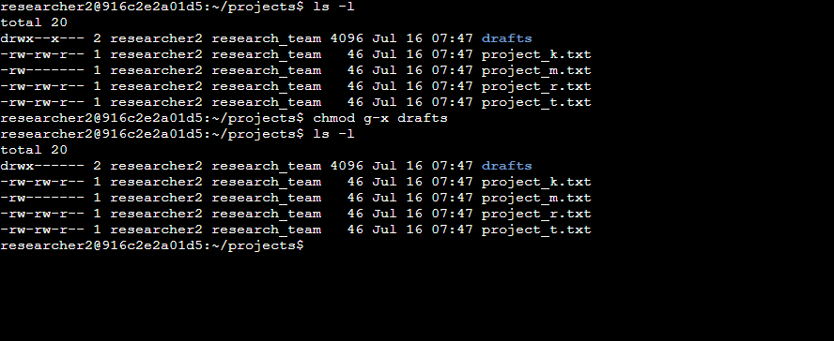

In this part,i had to change the permission of drafts directory and make no one have access of it except the user since the group has now access of it i had to change the permission

## Summary

I changed the permissions as per my organizations request by first listing all the permissions and then making changes by using chmod command